Jurnal BRIDA Kabupaten Gianyar
Volume X, Number X, Years
ISSN: 2355-4150 (Print) | 2579-8162 (Online)
Publication details, Including author guidelines
visit URL: https://www.ejournal.gianyarkab.go.id/

Title – Not More Than 12 Words Lucida Sans Font Size 18, Align Left, Capital Each Words

Author Name(s): (Font Gadugi Size 9)
Afiliation (Font Gadugi Size 9)

BRIDA Kabupaten Gianyar (as publisher) makes every effort to ensure the accuracy of all the information (the “Content”) contained in the publications. However, we make no representations or warranties whatsoever as to the accuracy, completeness, or suitability for any purpose of the Content. Any opinions and views expressed in this publication are the opinions and views of the authors and are not the views of or endorsed by BRIDA Kabupaten Gianyar. The accuracy of the Content should not be relied upon and should be independently verified with primary sources of information. BRIDA Kabupaten Gianyar shall not be liable for any losses, actions, claims, proceedings, demands, costs, expenses, damages, and other liabilities whatsoever or howsoever caused arising directly or indirectly in connection with, in relation to, or arising out of the use of the content.

Jurnal BRIDA Kabupaten Gianyar is published by BRIDA Kabupaten Gianyar comply with the Principles of Transparency and Best Practice in Scholarly Publishing at all stages of the publication process. Jurnal BRIDA Kabupaten Gianyar also may contain links to web sites operated by other parties. These links are provided purely for educational purpose.
This work is licensed under a Creative Commons Attribution-ShareAlike 4.0 International License.
Article History
Received:
Revised:
Accepted:

How to cite this article (APA)
Last Name, First Name. (Years). Title. Jurnal BRIDA Kabupaten Gianyar, Vol(No), Pages. doi:xxxxxxxxxxxxxx

*Corespondence regarding this article should be addressed to:
Name of Corespondence Author (Font Gadugi Size 9)
Email: (Font Gadugi Size 9)

Title – Not More Than 12 Words Lucida Sans Font Size 18, Align Left, Capital Each Words

Author 1*, Author 2, and Author 3 (Lucida Sans, Font 10)
Afiliation, Country (Lucida Sans, Font 10)
Abstract: The abstract should be written in one paragraph and should be not more than 250 words. Times New Roman, font size 10, single spacing. Follow the following pattern: General statement about the importance of the topic, gap in literature or discrepancies between theories and practices, purpose of study, method, main findings, and result.

Keywords: Employee performance; job satisfaction; workload; work motivation
Heading (9 pt Lucida sans, Bold, Align Left)
Body (9 pt Lucida sans, justify, spacing 1.0pt)
Keyword (9 pt Lucida sans, Bold, Align Left)

Introduction (Lucida Sans, Font 12)
In Introduction, Authors should state the objectives of the work at the end of introduction section. Before the objective, Authors should provide an adequate background, and theoretical frameworks which are used in order to discuss the problems as the objective of the research to show which is the best of previous researches, to show the main limitation of the previous researches, to show what do you hope to achieve (to solve the limitation), and to show the scientific merit or novelties of the paper. Avoid a detailed literature survey or a summary of the results. The article should be between 10-13 pages, single spaced, 10 point lucida sans font, excluding references and appendices. Use no indent for the first paragraphs and do not leave a space between paragraphs. The following paragraphs is indented first line 1.25cm.
- Heading/1.Introduction, (12 pt Lucida Sans, Bold, Align Left)
- Body (10 pt lucida sans, justify, single spacing 1.pt)

Concept and Hypothesis (Lucida Sans, Font 12)
In Concept and Hypothesis, Authors should state the concept and hyphotesis which used in the research by very short literature survey.
- Heading/1.Concept and Hyphothesis, (12 pt Lucida Sans, Bold, Align Left)
- Body (10 pt lucida sans, justify, single spacing 1.pt)

Method
In Methods, Authors should state the methods which used in the research by very short literature survey in order to record the existing solutions/method.
- Heading/1.Method, (12 pt Lucida Sans, Bold, Align Left)
- Body (10 pt lucida sans, justify, single spacing 1.pt)

*Correspondence regarding this article should be addressed to:
Name of Correspondence Author (Gadugi, Font 9). Afiliation-Country (Gadugi, Font 9).
Email: email of correspondence email (Gadugi, Font 9)

Result and Discussion
Results should be clear and concise. In the Discussion, it is the most important of your article. Make the discussion correspond with the finding but do not reiterate the discussion.
- Heading/1.Result and Discussion, (12 pt Lucida Sans, Bold, Align Left)
- Body (10 pt lucida sans, justify, single spacing 1.pt)

Conclusion
Conclusions should answer the objectives of the research. Tells how your work advances the field from the present state of knowledge. Without clear Conclusions, reviewers and readers will find it difficult to judge the work.
- Heading/1.Conclusion, (12 pt Lucida Sans, Bold, Align Left)
- Body (10 pt lucida sans, justify, single spacing 1.pt)

Reference
Use APA (American Psychological Association) Style for of the reference.
- 10 pt Arial, spacing 1.0, Hanging 1cm
Example:
- For Journal: Last Name, First Name. (Years). Title of Research. Name of Journal. Volume (Number). Pages. Doi/link
- For Book: Last Name, First Name. (Years). Name of Book. City: Publisher
- We Suggest to Used Reference Manager like Mendeley, Zotero, End Note, etc to facilitate you in citation

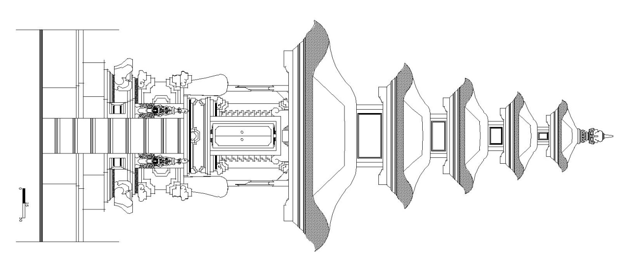
Example of Picture and Tabel
Figure 1. Title
(Sumber: Dokumentasi PT. Bali Sraya, 2008)

Table 1. Title of Table
No | Item 1 | Item 2 | Item 3 | Item n
(Source)

